WALKING IN THE AIR (THE SNOWMAN 1982)
biharizsuzsanna

(Aled Jones)
We're walking in the air
We're floating in the moonlit sky
The people far below are sleeping as we fly
We're holding very tight
I'm riding in the midnight blue
I'm finding I can fly so high above with you
Far across the world
The villages go by like trees
The rivers and the hills
The forest and the streams
Children gaze open mouth
Taken by surprise
Nobody down below believes their eyes
We're surfing in the air
We're swimming in the frozen sky
We're drifting over icy
mountains floating by
Suddenly swooping low on an ocean deep
Arousing of a mighty monster from its sleep
We're walking in the air
We're dancing in the midnight sky
And everyone who sees us greets us as we fly
sleeping drifting riding finding holding surfing swimming walking floating swooping dancing

We're __________in the air
We're __________ in the moonlit sky
The people far below are _________ as we fly
We're ________ very tight
I'm __________ in the midnight blue
I'm _________ I can fly so high above with you
Far across the _______ 
The _______s 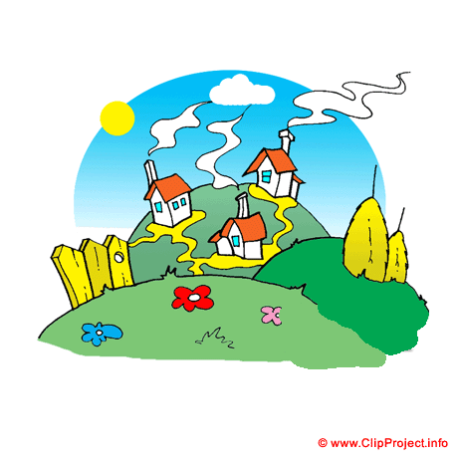go by like ____ 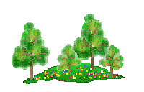
The __________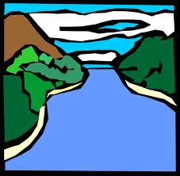 and the ___ 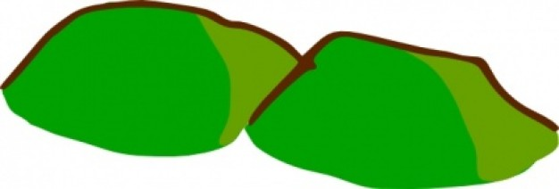
The _________ 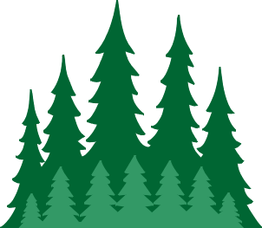 and the _____s
Children gaze open _____
Taken by surprise
Nobody down below believes their ______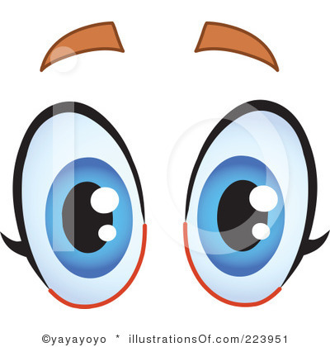
We're _________ in the air
We're _________ in the frozen ____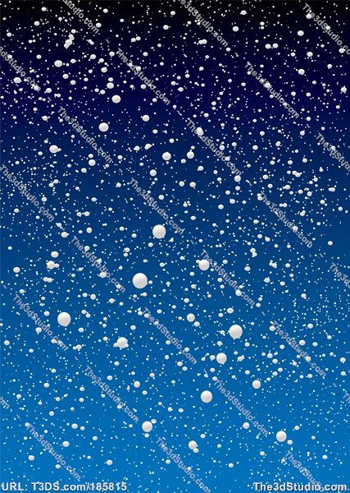
We're _________ over icy
mountains floating by
Suddenly _________ low on an ocean deep
Arousing of a mighty monster from its sleep
We're _________ in the air
We're _________ in the midnight sky
And everyone who sees us greets us as we fly

